01 / IDENTITY SYSTEM AND PRODUCT FOUNDATIONS

Cosmik brand kit
  - One recognizable identity across websites, tools, project pages, and documents.
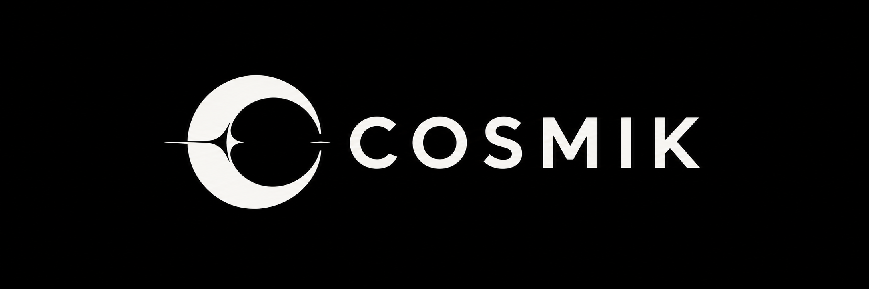
Cosmik is Matthew Downs’s independent open-source gaming workshop. It covers modern reimplementations of older open-source games and engines, mods and tools, and original games.

Brand foundation
Open-source games, mods, and tools. Reimagining classic technology and building something new.
Reimagine covers older open-source games and engines. Extend covers mods and tools. Create covers original games and experiments. These are the published areas of work.

How to use this edition
Approved means existing artwork or published language. Proposed means a supporting specification awaiting review. Archive means a reference that must not be treated as a production master.
This edition adds tested semantic themes, component specimens, a reusable document template, and an explicit asset handoff. The traced symbol has been accepted. The complete outlined wordmark and horizontal lockup are still separate production work.
02 / APPROVED ORIGINALS AND ACCEPTED TRACE

Identity assets and authority
Use one approved source for each identity role. Keep the original raster compositions as references; do not silently replace them with a generated or traced interpretation.
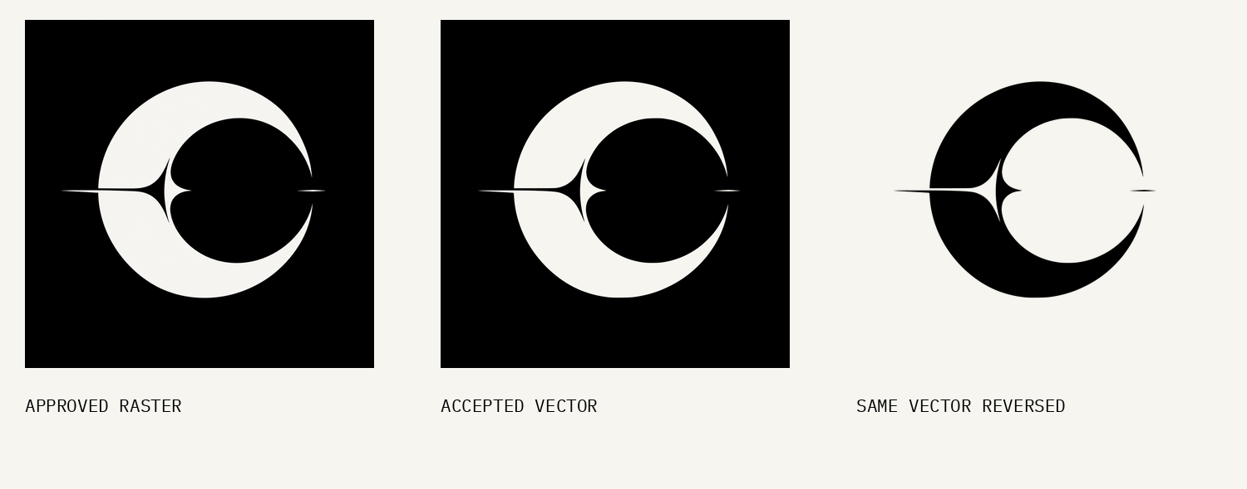
Asset | Current status | Allowed use
Original square and banner | Approved raster compositions | Intact, proportionally scaled black-background placements
Traced symbol and exact reverse | Accepted vector master | Reusable symbol master; proof in the final medium
Generated light PNGs | Archived alternatives | Reference only; geometry differs from original
Outlined wordmark and lockup | Not yet supplied | Do not recreate with Inter or auto-label a substitute

One shape across colors
The vector reverse uses the same geometry with a different fill. The separately generated light PNGs do not. Derive every transparent and solid-background export from the accepted vector source.

Using the name in live interfaces
A live identity label is allowed: “Cosmik”, Inter Medium 500, 20 px, normal tracking, centered vertically beside a 48 px square symbol with a 12 px gap. It is an interface label, not a replacement COSMIK wordmark.
03 / PROPOSED SYSTEM

Logo construction and proof
Keep original aspect ratios. For the symbol, clear space is at least 10% of its visible flare-to-flare width on every side. The full supplied square canvas already exceeds this minimum.
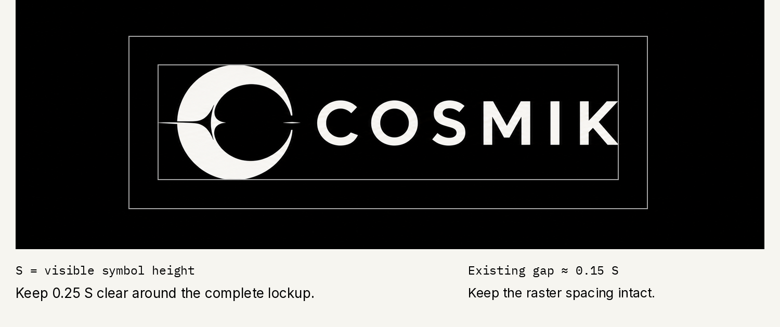
For the horizontal lockup, S is the visible emblem height. Keep 0.25 S around the complete visible lockup. The current raster’s gap is about 0.15 S and its letter height about 0.39 S. These measurements record the artwork; do not rebuild it from the ratios.
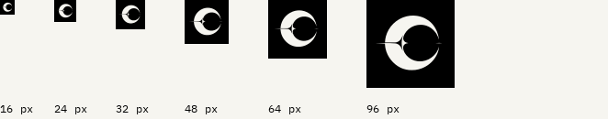
Use 48 px for brand-led interface placements. Use 32 px for constrained avatars. At 16–24 px the flare loses definition. No optically redrawn small-size master is included. The strip is placed at 96 ppi; PDF zoom changes apparent size.
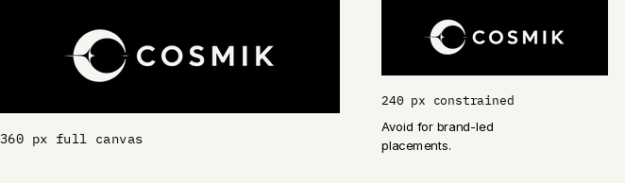
Use the full banner from 360 px wide. For print, begin at a 15 mm symbol or a 75 mm banner and proof on the actual stock. These are provisional visual recommendations, not universal reproduction limits.
04 / PROPOSED SYSTEM

Typography across media
Inter is the reading and interface family. IBM Plex Mono is for code and short technical metadata. The original COSMIK wordmark remains separate artwork.
Open-source games,
mods, and tools.
README.md / 0123456789 / Aa Bb Cc
Web role | Font and weight | Size / line height
Display | Inter 600 | 48 / 1.10; small 34 / 1.15
Section / project heading | Inter 600 | 30 / 1.20 and 22 / 1.30
Body | Inter 400 | 17 / 1.55
Navigation and button | Inter 500 | 15 / 1.40
Code and short metadata | IBM Plex Mono 400 | 14 / 1.50

Document role | Font and weight | Points / line height
Title / section / subhead | Inter 600 | 30 / 1.10; 20 / 1.20; 14 / 1.25
Body | Inter 400 | 11 / 1.40
Table / code / caption | Inter 400 / Plex Mono 400 | 10 / 1.20; 9.5 / 1.30; 9.5 / 1.20

Use sentence case and 0 tracking. Only short uppercase metadata gets 0.06 em tracking. Keep reading columns near 65 characters. Do not use all-caps body copy, artificial condensed type, or monospace for long prose.
The bundle includes official Inter 4.1 static desktop fonts, web font files, IBM Plex Mono Regular, and their OFL notices. Install the desktop fonts to edit Word templates. Preserve the licenses when distributing font files. PDF fonts are embedded.
05 / PROPOSED SYSTEM

Color and semantic themes
The identity remains black and warm off-white. Product surfaces use a neutral scale with complete light and dark roles. Exact sRGB tokens are proposed implementation choices, not pixel-perfect extractions from the textured artwork.
Semantic role | Dark theme | Light theme
Canvas | #000000 | #F6F5F0
Surface | #121212 | #FFFFFF
Raised surface | #1F1F1F | #E8E7E3
Primary text | #F6F5F0 | #000000
Secondary text | #A3A3A3 | #666666
Functional boundary | #767676 | #767676

Use roles rather than raw grays
Product code consumes semantic tokens such as canvas, surface, text, and border. Primitive colors are only the ingredients. Switch the whole theme mapping together; never change text without its associated surfaces.
Tested pair | Contrast | Use
Paper on Black | 19.23:1 | Primary text
Muted dark on Raised dark | 6.53:1 | Secondary text
Muted light on Raised light | 4.64:1 | Secondary text
Functional border on Raised dark | 3.62:1 | Essential boundary

Values are conservative two-decimal figures from solid sRGB pairs. Confirm against the included validation report. Required text uses at least 4.5:1; necessary control boundaries use at least 3:1. Decorative separators are exempt from the latter only when they convey no essential information.

Print and color status
The reference palette is sRGB. No universal CMYK or Pantone match is specified. Use the original paper color, test black coverage, and approve a physical proof for each print process and stock. No accent color is part of this baseline.
06 / PROPOSED SYSTEM

Actions and keyboard focus
Controls should explain the next step and behave consistently. The offline component reference consumes the same tokens as this guide. Its states are examples, not a full application framework.
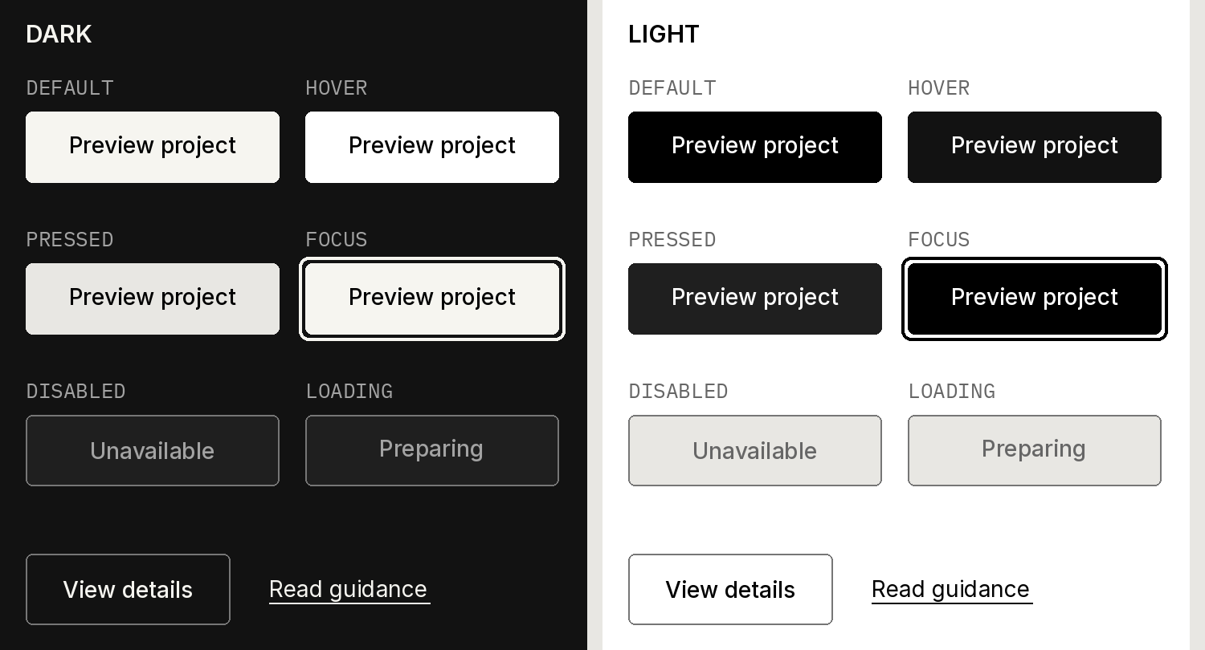
Drawn specification using the token values. Browser rendering and keyboard checks remain pending; see the validation report.
State | Required behavior
Default | One primary action per local task; use specific verb labels.
Hover and pressed | Change fill without changing layout; retain text contrast.
Keyboard focus | Visible 2 px outline with offset; do not clip it or hide it under overlays.
Disabled | Native disabled behavior plus a reason when the next step is unclear.
Loading | Keep the control width stable; use a meaningful loading label and expose busy state.

Standalone targets are at least 44 × 44 CSS px as a house standard. WCAG 2.2 AA has a 24 px minimum with exceptions; the larger house target gives touch and pointer users more room.
Underline inline links. A button performs an action; a link navigates. Keep keyboard order meaningful and show the same useful content for touch, pointer, and keyboard input.
07 / PROPOSED SYSTEM

Forms and functional messages
Labels, instructions, errors, and status remain understandable without relying on color. The monochrome palette works because the message and structure carry the meaning.
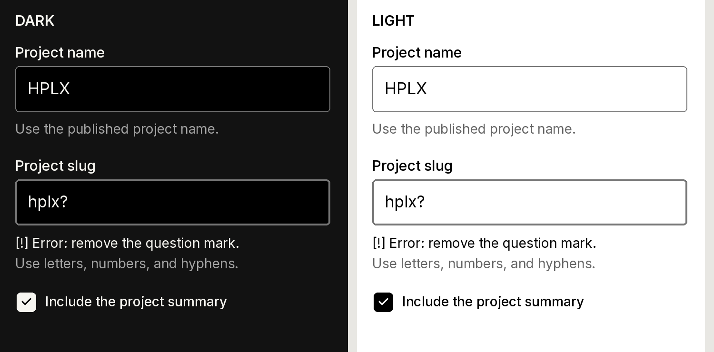
Drawn specification. The offline HTML supplies the actual editable controls and state examples.

Field contract
Put a persistent label above the field. Use helper text for the expected format. A placeholder can show an example but cannot replace the label. Identify an error in words, connect it to the field, and say how to fix it. Preserve the entered value.

Status contract
Use explicit labels such as Error, Saved, or In development. Pair important status with a distinct symbol or text treatment. Never use a shade change alone. Success and error messages can use the same neutral foreground when their words remain clear.

Accessibility checks before shipping
Check keyboard access, visible focus, programmatic names, error associations, and announcements for asynchronous results. Test 320 CSS-px reflow, 200% text enlargement, and reduced motion. The kit’s contrast checks and specimens are evidence for this reference, not certification of every future product.
08 / PROPOSED SYSTEM

Layout that scales
Use a 4 px base rhythm. Common steps are 8, 16, 24, 32, 48, 64, and 96 px. Choose one dominant alignment and group related controls more tightly than unrelated sections.
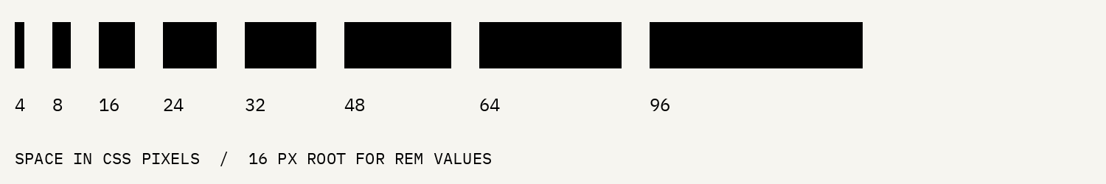
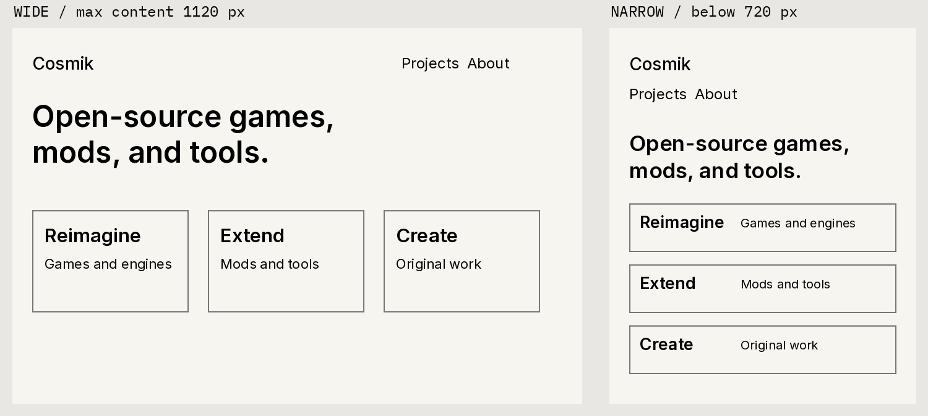
Structural diagram, not a browser screenshot. Preserve all content when columns stack.
Rule | Wide layout | Narrow layout
Outer gutter | 24 px minimum; center within 1120 px | 24 px, with content allowed to wrap
Columns | Two or three only when content fits | Single column below 720 px
Major section gap | 64–96 px | 48 px below 720 px
Display type | 48 px / 1.10 | 34 px / 1.15 below 720 px
Navigation and actions | Wrap cleanly when necessary | Stack or wrap; preserve target sizes

Use 4 px corner radii for controls and surfaces. Avoid ornamental shadows, repeated logo decoration, and dense badge clusters. Code blocks may scroll horizontally inside their own container; the page itself must reflow.
09 / PROPOSED SYSTEM

Documents people can reuse
Use the included editable technical-note template as a starting point. It carries the identity through type, spacing, restrained branding, and clear hierarchy rather than an oversized cover page.
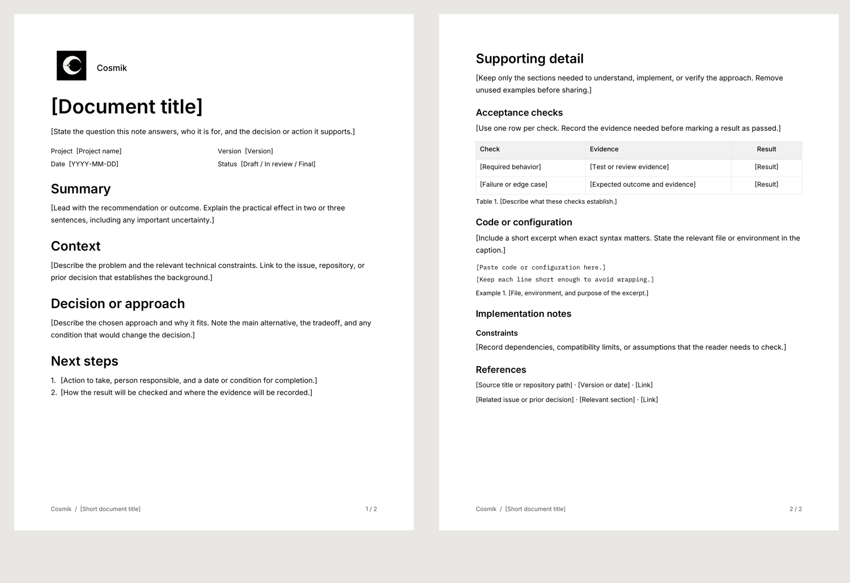
Element | Template rule
Page | Letter portrait; 20 mm margins. Reflow and review if adapting to A4.
Branding | Intact approved raster or live identity label; no retyped wordmark.
Reading | Inter 11 pt / 1.4; left aligned; real Word heading styles.
Tables and code | Use tables for comparable records; repeat header rows. Use Plex Mono for code.
Figures and links | Add a caption and meaningful alt text; use descriptive, visible links.
Footer | Version or document status and page number; no invented legal footer.

Replace bracketed fields and remove instruction text. Keep the document’s title and first paragraph specific to its purpose. Review every exported PDF page after substantive changes; missing fonts can alter the Word layout.
10 / PROPOSED SYSTEM

One umbrella for distinct projects
Cosmik is the parent identity. Each project has its own name, purpose, status, and upstream obligations. A project can have its own visual mood while keeping the endorsement and utility type consistent.
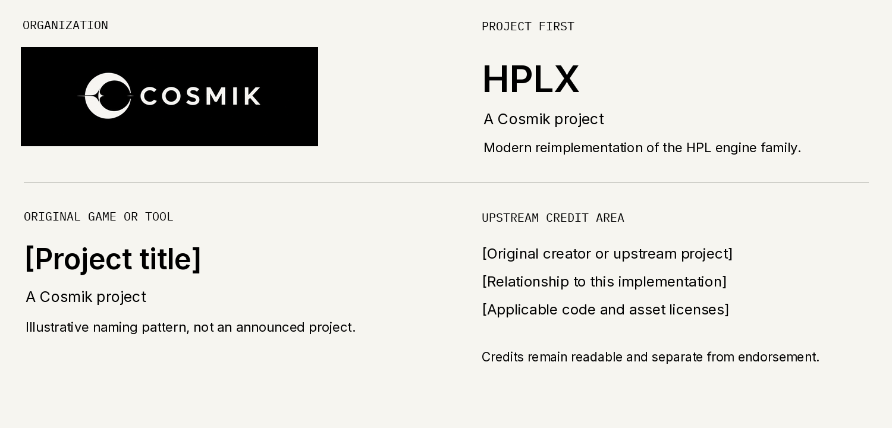

Endorsement pattern
Let the project title lead. Place “A Cosmik project” beneath the title or in the footer, Inter 400 at 14 px on the web or 9.5 pt in a document. Keep at least 16 px or 4 mm between the title block and endorsement; do not combine marks into a new logo.

Names and claims
Use Cosmik in prose and cosmik-labs for the handle. HPLX is the engine project; the separate Amnesia: The Dark Descent implementation is another project. Do not imply official affiliation, ownership of game IP, or common licensing across all code and assets.
Keep original creator credits and license notices readable and separate from the Cosmik endorsement. The generic original-project example above is a layout pattern, not an announced product.
11 / PROPOSED SYSTEM

Voice imagery and motion

Voice
Write like an independent developer sharing useful work. Say what a project does, what works today, and what someone can do next. Use “I” for Matthew’s personal updates and “Cosmik” for neutral descriptions. Do not imply a larger team or formal company.
Published description: “Cosmik is an independent open-source gaming workshop, building games, mods, tools, and modern reimplementations of classic game technology.”
Useful update pattern: “[Feature] now works in [build or branch]. [Known limitation] is still being worked on. See [link] for the current setup instructions.” Replace each bracket with a verified fact.

Imagery and icons
Use real project screenshots, diagrams, or relevant artwork when they explain the work. Preserve proportions; crop only when essential information remains visible. Keep horror-specific imagery inside the relevant project. Avoid generic space wallpaper, decorative starfields, and artificial glow as default Cosmik styling.
For utility icons, use one consistent stroke family, a 24 px drawing grid, and a clear accessible name. Decorative icons are hidden from assistive technology. A visible icon does not replace an ambiguous action label.
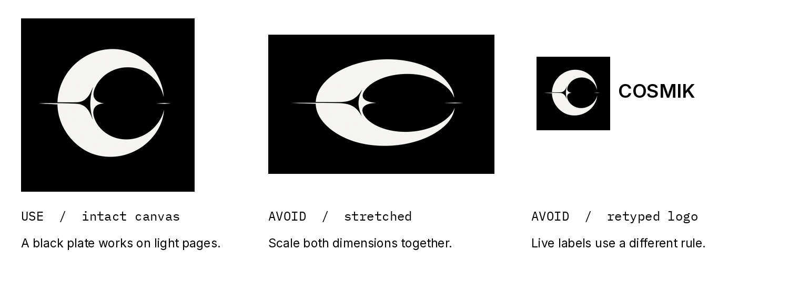

Motion under exploration
The current exploration starts with a centered emblem, slides it left, and reveals widely spaced O S M I K letters. The final lettering, spacing, and timing remain under review. Keep recurring interface branding static. For reduced motion, show the complete identity immediately; never delay essential content for a logo reveal.
12 / ADOPTION AND SOURCE REFERENCES

Handoff and release checks
The bundle separates approved originals, accepted vector artwork, archived experiments, implementation tokens, component specimens, and document templates. It is prepared for cosmik-labs/brand; nothing is published by this guide.
Location | What it is
assets/approved-raster/ | Original approved square and banner, unchanged
assets/vector/ | Accepted traced symbol and exact color reverses
assets/archive/ | Earlier generated light alternatives, not masters
tokens/ and specimens/ | Synchronized semantic CSS/JSON and offline component reference
templates/ and fonts/ | Editable document starter, proof PDF, and licensed font files
references/ and asset-manifest.json | Validation, source records, font licenses, and checksums

Before adoption
1. Use the accepted traced symbol as the canonical emblem; preserve its source record.
2. Approve the supporting type, semantic themes, and component behavior.
3. Commission or prepare a faithful outlined wordmark and complete lockup; proof tiny icons separately.
4. Set brand-asset reuse terms and confirm any external rights before public distribution.
5. Re-test real product screens and print outputs; keep versioned assets and retire superseded copies.
Matthew owns identity decisions. Contributors can propose changes with a before/after proof, affected files, and validation results. A new product should reuse the system; changes to the logo or core type/palette need explicit review.

Primary references
Cosmik published profile and source version
Inter downloads and license
IBM Plex Mono official package and license
WCAG text contrast
WCAG non-text contrast
WCAG target size and exceptions
WCAG focus visibility
The full validation report records the tested reference, results, and remaining limits. Version 0.2 is a review draft, not a declaration that all downstream products are accessible or all brand rights are cleared.

